Attendance:
To enter attendance for your group meetings.
Select the Attendance tab, click the Mark Attendance button.

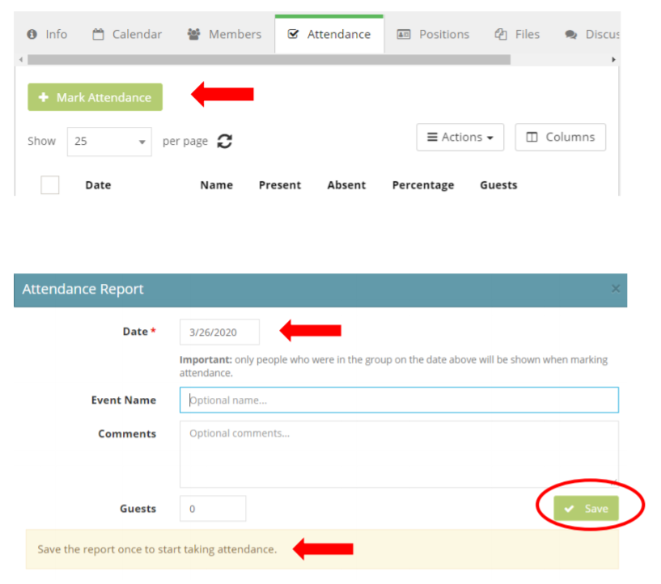
The date will default to the current date but it may be adjusted as needed, you also have the option to title your attendance report. (ex: Chewbacca led group, Meeting held at beach, etc.)

Click Save.

Your group members will show in this window.
Clicking on the person will add them to the members in attendance.
Changes are automatically saved.

