LifeGroup Leaders:
How To Maintain Your Group in OneChurch

As a LifeGroup Leader you know how important each member of your group is, and Grace Church knows how important the hundreds of LifeGroup members are. Using the OneChurch database helps us to see and know each person, and to care for them as members of the body of Christ. We want to equip you as a leader to maintain your group data – especially the details of when/where you meet, the description of your group, and the members of your group. Thank you for your leadership and help with maintaining this data. If you need help or have questions, please contact data@whoisgrace.

Your group home page shows day/time/location your group meets along with the group description. You’ll also see tabs across the top of the window.
(Note: your tabs may differ slightly from picture)

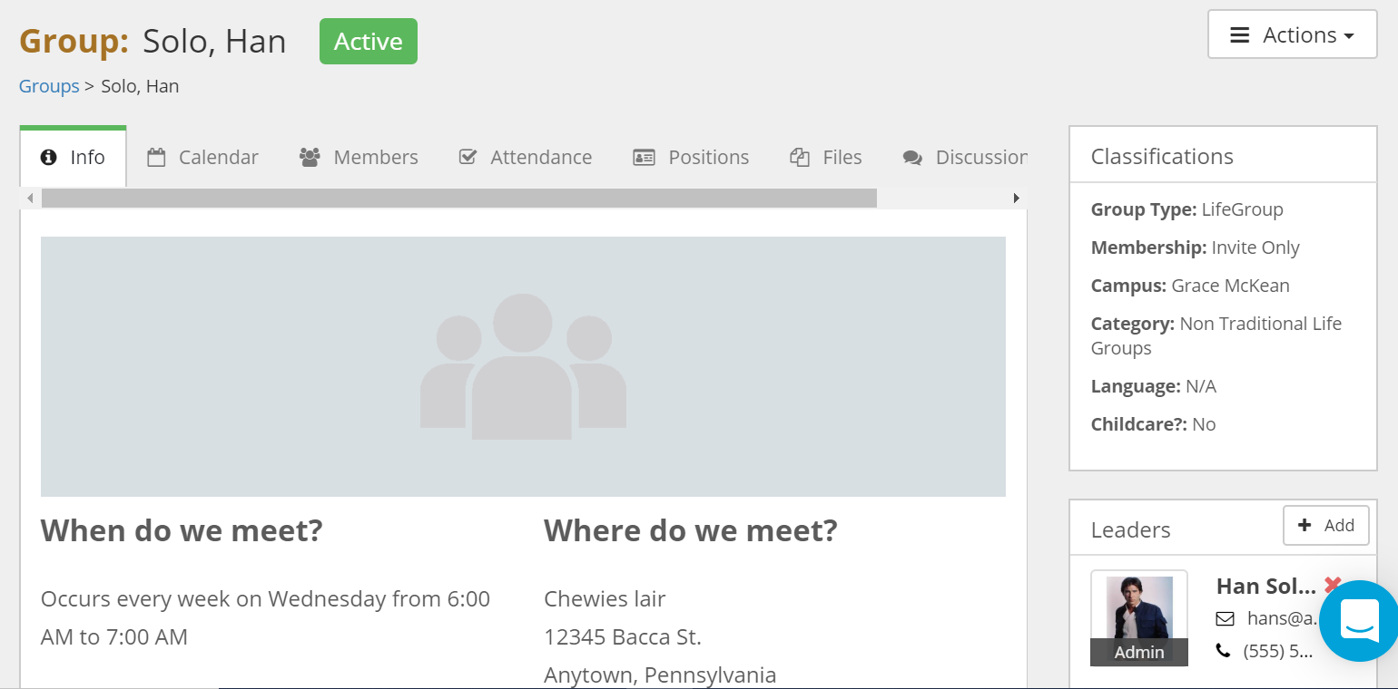

With the Actions tab on the top right of the window, you may edit your group description, day/time/location of your meeting or upload a file to your group.
Here are samples of group descriptions:
“Our group is a wonderful gathering of people seeking the Lord. We are of various ages...early thirties to eighty. We are both men and women, married and single. Our time together consists of fellowship, prayer and Bible study. We share a dinner together at least once a quarter.”
“Our group is made up of couples and kids (but is not exclusively for couples). We typically discuss the sermon series every week and have dinner together 1-2 times a month. We rotate homes for hosting between North East, Wattsburg, and Harborcreek.”
“We meet every other Friday night to share food and fellowship with married couples looking to grow in relationship with Jesus. Children are welcome and we have a babysitter who watches them for 1.5 hours in the play room. The adults can enjoy good conversation with less distraction! Childcare is $5/family!”

Click on the Member tab and you’ll see your group members, along with other attributes, adjustable by clicking on the Columns button.
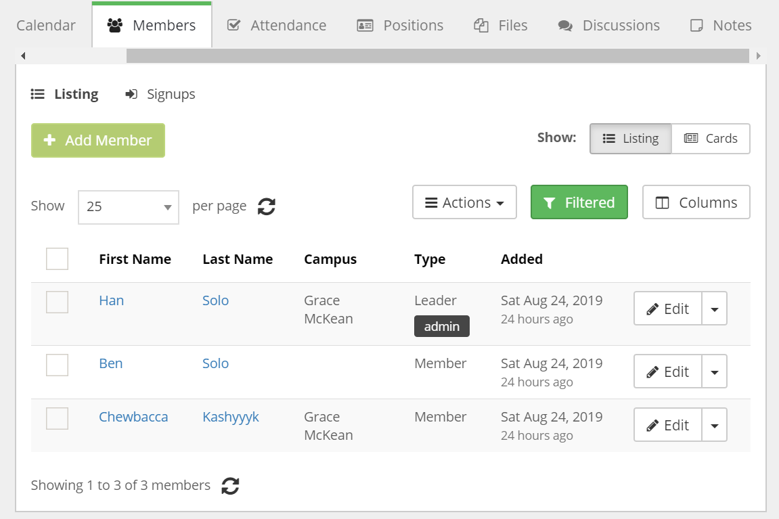

As members join your group, please add them by clicking the Add Member button. This will pop up a new window where you will type in the name, and select member/leader, or whether this person will be an admin (allowing them more control over the group information) You’ll also see a section to add any notes, if desired. Be sure to click Save at the bottom of the screen when you’ve finished.
Note: This step is particularly important for those that join your group without having connected through the workflow process.

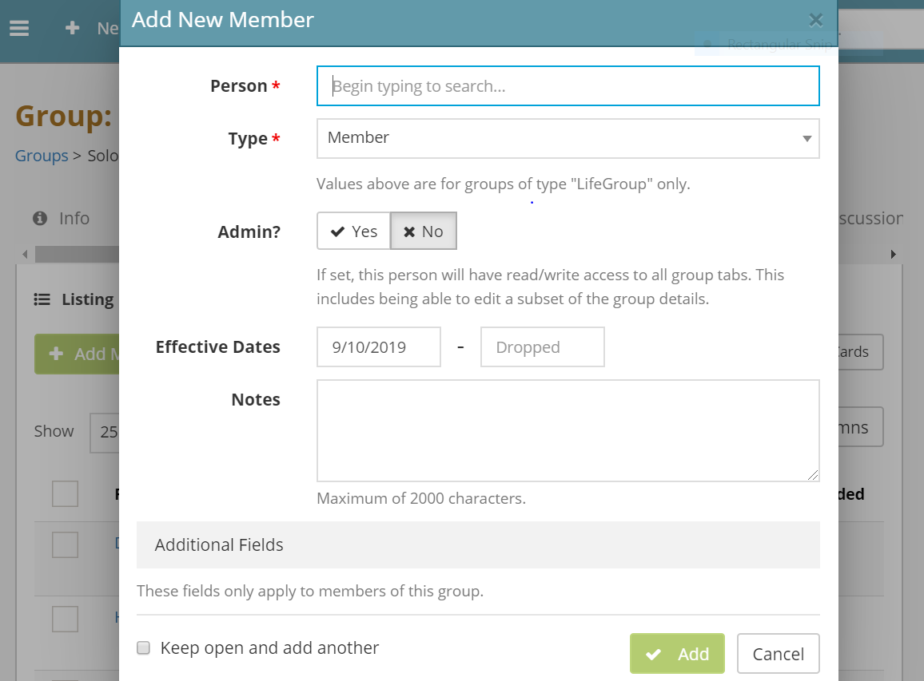

To remove a member from your group click on the edit button. Add the date the member left the group in the box marked Dropped. Click Save.

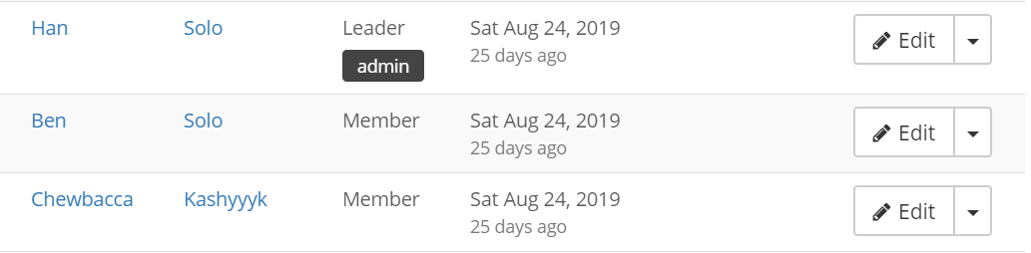
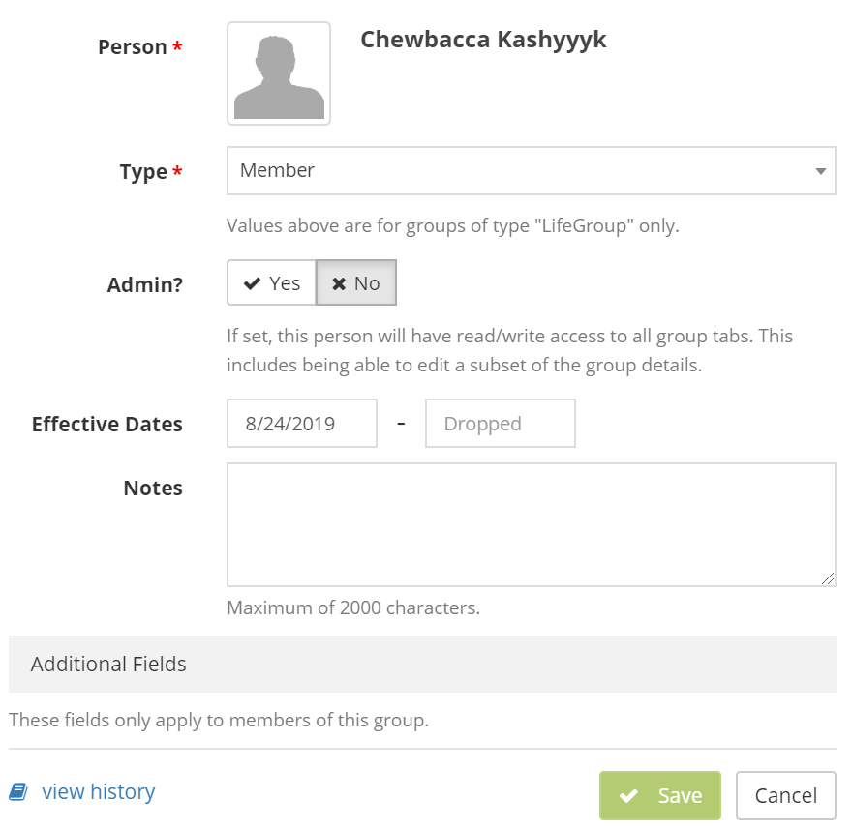

Attendance:
To enter attendance for your group meetings select the Attendance tab, click the Mark Attendance button.

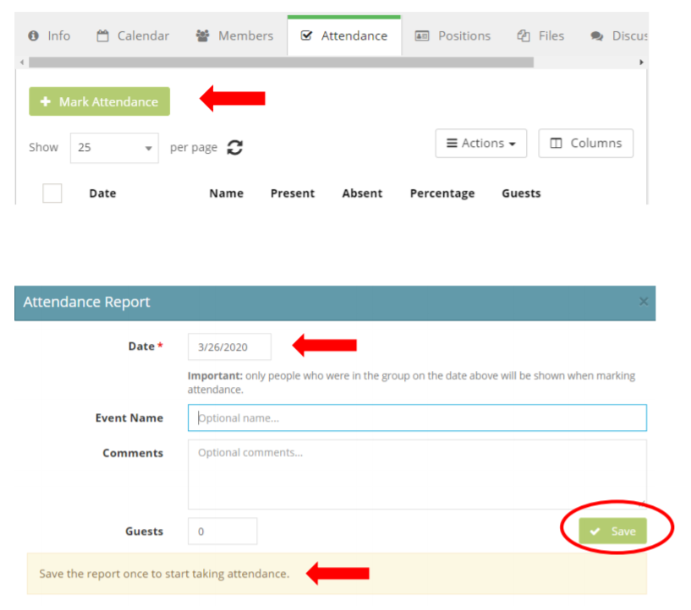

The date will default to the current date but it may be adjusted as needed, you also have the option to title your attendance report. (ex: Chewbacca led group, Meeting held at beach, etc.)

Click Save.

Your group members will show in this window.
Clicking on the person will add them to the members in attendance.
Changes are automatically saved.
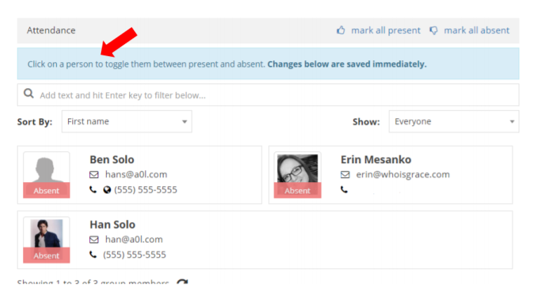

The Discussions tab is available for any group communication. It can only be initiated by the group admins, but once initiated any member may comment.

